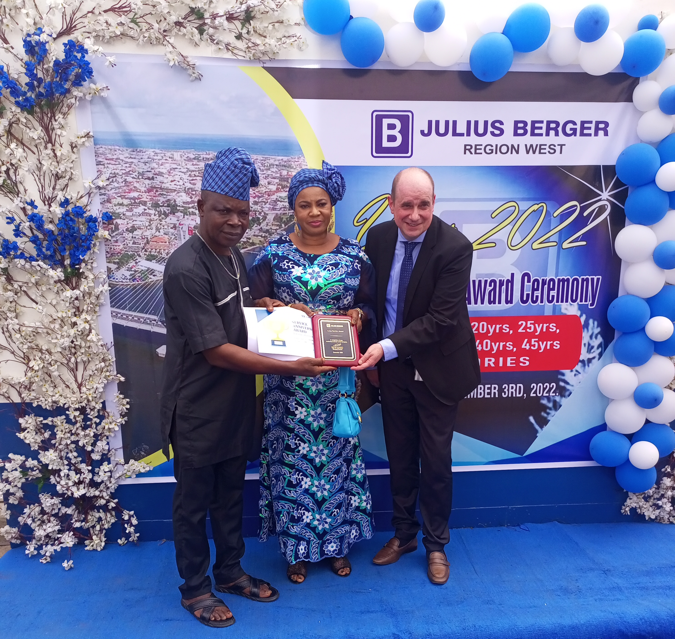
Region West Regional Manager, Commercial, Alexander Bauer presenting an Award to Mr John Ubanni as Mrs Ubani savours the moment at the JBN Long Service Awards 2022 event recently.

